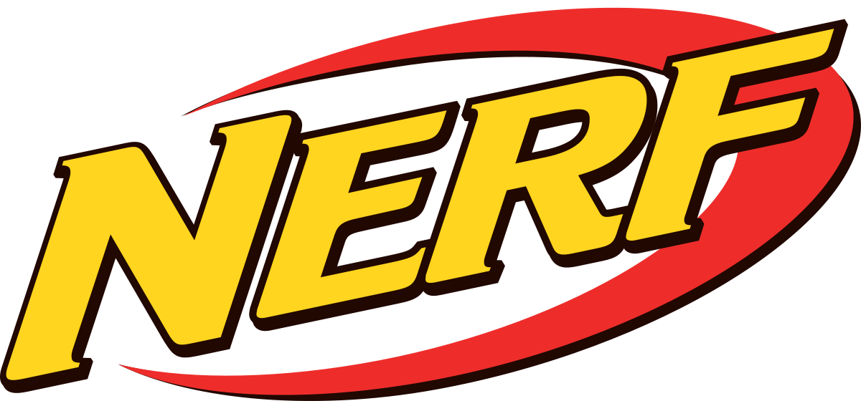
NIGHT !
October 13, 2023
November 17, 2023

6:30-8:00pm

Time
6:30-8:00pm

Where
Fergus Falls YMCA

Ages
6-12 years old

Cost
Member: $12
Potential Member: $17

Registration
YMCA Front Desk or Online by the Wednesday prior to Date.

Limited Spots!

Do your kids like Nerf battles? Bring them to the YMCA on Friday for our Nerf Night! We will separate children out into teams. A course will be created in the gym using cardboard boxes and other safe materials as obstacles for cover. We will supply the darts and the safety goggles, children bring their own Nerf blasters.

Bring your own Nerf Blasters!

